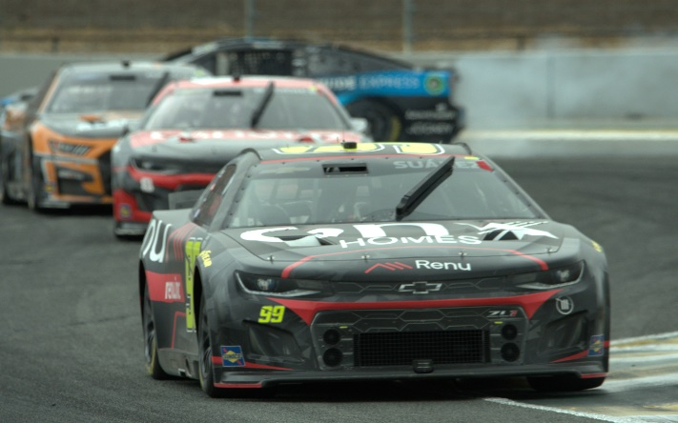
- MULTIPLE WAYS TO WIN -
  - CUP SEASON– 3 Race Segments - 13*13*10
  - Paying up to 3rd place position*.
  - Steve’s Big 3 Challenge
  - Pools: Short, Premium, Superspeedway and Road Skills
  - SELECTING CARS NOT DRIVERS
- Scoring: 1 st place = 40* points 40th place = 1 point
  - $10 million dollar budget
  - Select 8 CARS (no more or less) from the list attached
  - Do NOT exceed your $10 million budget
  - Daytona picks are available before the green flag!!
- FIRST CAR change right after The Daytona 500 Maximum 4 Drivers
- Segment Change: ALL 8 cars / drivers
- Change: up to 4 of your 8 Cars mid segment only. See scoring.
- Car Value holds precedence of car/driver value for substitutions
- Driver /Car value subject to reevaluation after driver move.
- Email CAR # change and new team value with date and $ amount.
- Keep it simple: Use an email and please list your team name.
- Changes must be made prior to GREEN FLAG! for race changes.
- Entry fee: $50.00
- Entry fee due payable by March 1, 2023. PAY by mail, or PayPal .
- Email Application Information to: Nascarmania2020@gmail.com
- See Website for CAR Values, email or call to get the list emailed.
- ONLY email your CAR picks as soon as possible or by Feb 19th.
- Any questions don’t hesitate to call. Good luck and have fun!

Randy Jones Cel 1-707-889-0291
Email: Nascarmania2020@gmail.com website: www.nascarmania.net
Pay online: See PayPal or call me for mailing address.

ENTRY FORM

Maniac: _____________________________________ Enclosed: $50.00

Team Name:___________________________________________________

Street:_______________________________City:_____________St:_____

Phone: ______________________ Email: ___________________________

